Reviewer Note: Reviews for this pattern are due Sept 21st.
Data Transfer HashMap

A client needs to exchange bulk data with the server in a generic fashion.
How can arbitrary amounts of data be efficiently transferred across tiers in a generic fashion?
* * *
As discussed in the Data Transfer Object and Session Façade patterns, performance in an EJB system is realized by minimizing on the number of network calls required to execute a given use case. In particular, Data Transfer Objects provided a way to transfer data across a network in bulk, keeping the client from executing more than one network call to an EJB in-order to send or receive some data.
The most common way to use DTOs are to use Custom DTOs with a DTO Factory. Here, a new DTO is written for every new use case in the system, providing the client with an object based wrapper that acts as an envelope to transfer whatever data the use case requires. Despite the simplicity of this approach, using DTO’s in this manner also suffers several drawbacks:
High cost of change over time. The use cases in an application change over time. Different clients may need to access different views or subsets of server side data than were initially programmed. Using the Custom Data Transfer Object approach (even with DTO Factories), server side code (such as new DTOs and associated creation logic) must be written to satisfy the changing data access needs of the client. Once an EJB project has been launched, access to server side programmers tends to be expensive, as is the EJB re-deployment process.
Need to create a Data Transfer Object Layer. Data Transfer Objects create a new layer, which can explode to thousands of objects in a large application. Imagine a distributed system with 30 entity beans. Each of those thirty entity beans would likely have a Domain DTO to marshal their state to and from the client tier. The applications use cases may also require that data from those entity beans be used in several Custom DTOs. Thus, a medium sized system could require hundreds of DTOs, each with a particular DTO factory method to create it. Since the DTO layer generally represents attributes in the entity bean layer, changes in entity bean attributes will cause ripples that could require changes in multiple DTOs as well. In large applications, the DTO layer can prove to very difficult to maintain.
Client UI’s tightly coupled to the server. When using Custom DTO’s, each client UI is tightly coupled to the DTO it uses to populate itself. When the DTO changes, the client needs to be recompiled, even if the changes don’t necessarily affect that particular client. On a typical system with tons of different UI’s (imagine a large website with many JSPs), that represents a lot of dependencies that need to be maintained.
If the domain of an application is relatively simple, Data Transfer Objects are a great way to get the job done. If your domain requirements are more complex, an alternative to Data Transfer Objects may be needed; one that decouples the data being transferred from the object that contains the data, but still allows bulk access and transport of data across tiers.
Therefore,
Use HashMaps to marshal arbitrary sets of data between client and EJB tier.

Plain JDK HashMaps (available since JDK 1.2) provide a generic, serializable container for arbitrary sets of data, that can replace an entire layer of Data Transfer Objects. The only dependency been client and server side code is the naming conventions placed on the keys used to identify attributes, described later in this pattern.
Clients request HashMaps by going through the Session Façade. For example, for the use case of getting all data in an Account, a client would call a getAccountData method on the Session Façade, which would return a HashMap populated with all the data in an Account, as in figure X.1. Updates can be made on the same HashMap locally. Once updates are complete, the client simply passes the updated HashMap back to the session façade for updating.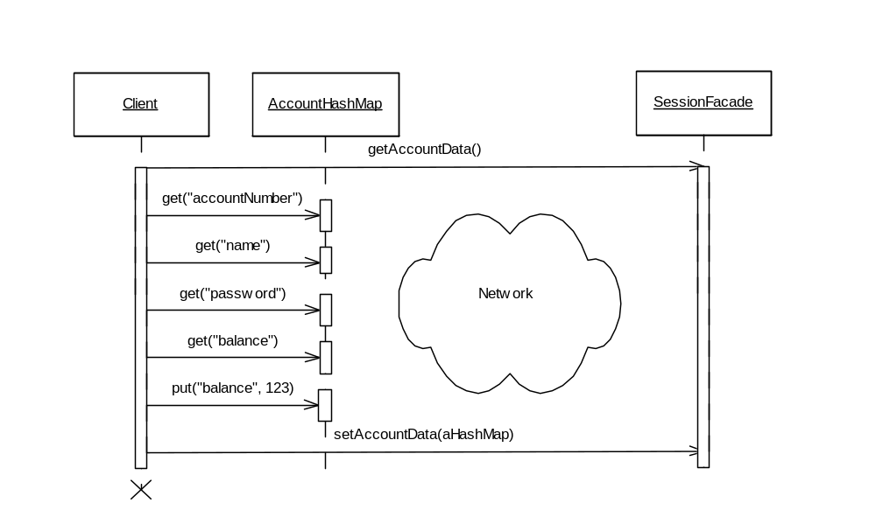
Figure X.1: Using a Data Transfer HashMap

Instead of implementing Custom Data Transfer Objects for every use case, a client can simply be passed a HashMap that contains different sets of data, as needed by the particular use case. For example, if a client needs needs a smaller subset of data than a HashMap with all the Account attributes, the Session Façade can simply coded to return a HashMap with fewer attributes.
Using a HashMap instead of a data transfer object comes at the cost of additional implementation complexity, since the client now needs to explicitly know the strings used as keys to query the HashMap for the attributes of interest. Furthermore, both the session façade and the client need to agree on the strings to be used by to populate and read from a HashMap. For a discussion of common solutions to this problem, see the Generic Attribute Access Pattern.
The advantages of using HashMaps for data transfer are:
Excellent maintainability - eliminates the Data Transfer Object layer. The extra layer of domain specific value objects and all that repetitive value object creation logic is now eliminated in favour of the generic reusable Map and Attribute Access interfaces. This represents a potential reduction of thousands of lines of code, particularly when used in conjunction with the Generic Attribute Access pattern.
One data object (Map) across all clients. A Map of attributes is reusable from the Session Façade down to the JSPs. In particular, using a Map as a data container significantly reduces the complexity of the JSP code, as pages don’t need to be written with use case specific Value Objects that are tightly coupled to the entity bean layer.
Low cost of maintenance over time. New views of server side data can be created that does not require any server side programming. Clients can dynamically decide which attributes to display.
The tradeoffs of using HashMaps for transferring data across the network are:
Need to maintain a contract for attribute keys. Whereas attribute names are hard-coded in the get methods of a DTO, clients need to remember the key values of attributes when using a HashMap. Furthermore, the client and server need to agree on the keys, creating an extra dependency between client and server.
Loss of strong typing/compile time checking. Using Data Transfer Objects, values passed by gets or sets were always of the correct type, any errors would be passed at compile time. Using HashMaps, attribute access must be managed by the client at runtime by casting objects to their correct type and associating the correct attribute type with the correct key.

.

